EX NO: 1

11/08/2021

**BASIC UNIX COMMANDS – CASE STUDY**

**AIM:**

To study the basic unix commands and know its use.

**COMMAND:**

**DATE:**

**Description:** date command is used to display the system date and time.

**Syntax:** date



**CAL:**

**Description:** cal command is a calendar command in Linux which is used to see the calendar of a specific month.

**Syntax:** cal

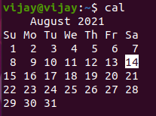

**WHO:**

**Description:** The who command is used to print the information about all the users who are currently logged in.

**Syntax:** who



**WHOAMI:**

**Description:** whoami command prints the username of the effective user ID.

**Syntax:** whoami



**CLEAR:**

**Description:** clear command is used to clear the terminal screen.

**Syntax:** clear

The previous works are present in the terminal screen before clear command is given.

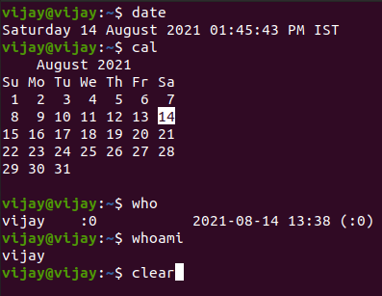

When clear command is given, the terminal screen is cleared.



**WHATIS:**

**Description:** whatis command in Linux is used to get a one-line manual page descriptions.

**Syntax:** whatis [options]





**HEAD:**

**Description:** The head command, as the name implies, print the top N number of data of the given input. By default, it prints the first 10 lines of the specified files. It is the complementary of Tail command.

**Syntax:** head <filename>

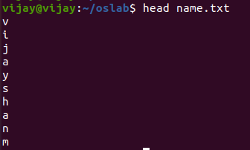

**TAIL:**

**Description:** The tail command displays the last part (10 lines by default) of one or more files or piped data. It can be also used to monitor the file changes in real time.

**Syntax:** tail <filename>

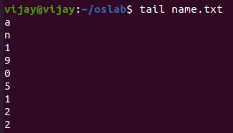

**CAT:**

**Description:** cat command is used to create single or multiple files, view content of file, concatenate files and redirect output in terminal or files.

**Syntax:**

**For seeing contents of file:** cat <filename>

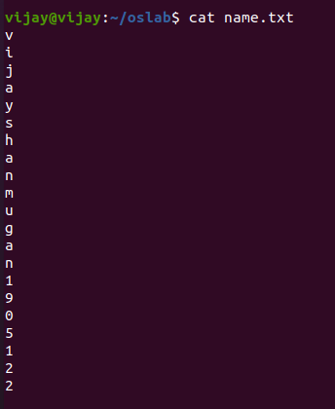

**For creating a file:** cat > <filename> followed by contents of file



**MORE:**

**Description:** more command also displays the content of the file like cat command but the difference is that, in case of large files, cat command output will scroll off the screen while more command displays output one screenful at a time.

**Syntax:** more <filename>

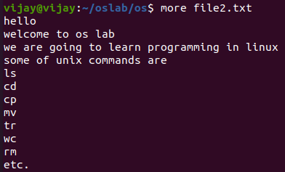

**LESS:**

**Description:** less command is same as more command but the difference is that less command automatically adjust with the width and height of terminal window, while more command cuts the contents as the width of the terminal window gets shorter.

**Syntax:** less <filename>



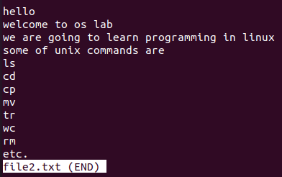

**REDIRECTION SYMBOL (>,>>):**

**Description:** Redirection can be defined as changing the way from where commands read input to where command sends output.

**Syntax:** commands with a single bracket ‘>’ overwrite existing file content

cat > <filename>

commands with a double bracket ‘>>’do not overwrite existing file content.

cat >> <filename>

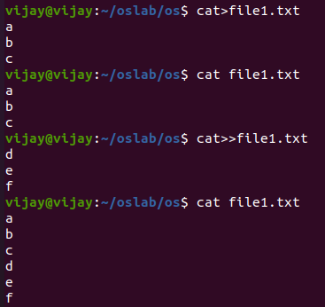

**INSERT:**

**Description:** insert command is used to insert a new text or file into another file at top or bottom of the file or after any particular line of file.

**Syntax:** sed ‘[line where new text or file to be appended] i\ text or <filename>’ <filename>

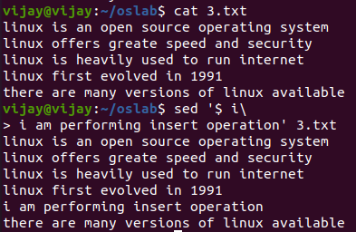

**APPEND:**

**Description:** append command is as more as like insert but here we append a text or file into another file at top or bottom or after any particular line.

**Syntax:** sed ‘[line where new text or file to be appended] a\ text or <filename>’ <filename>

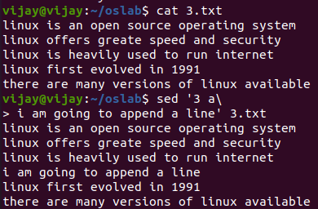

**MAN:**

**Description:** man command in Linux is used to display the user manual of any command that we can run on the terminal.

**Syntax:** man [keyword]



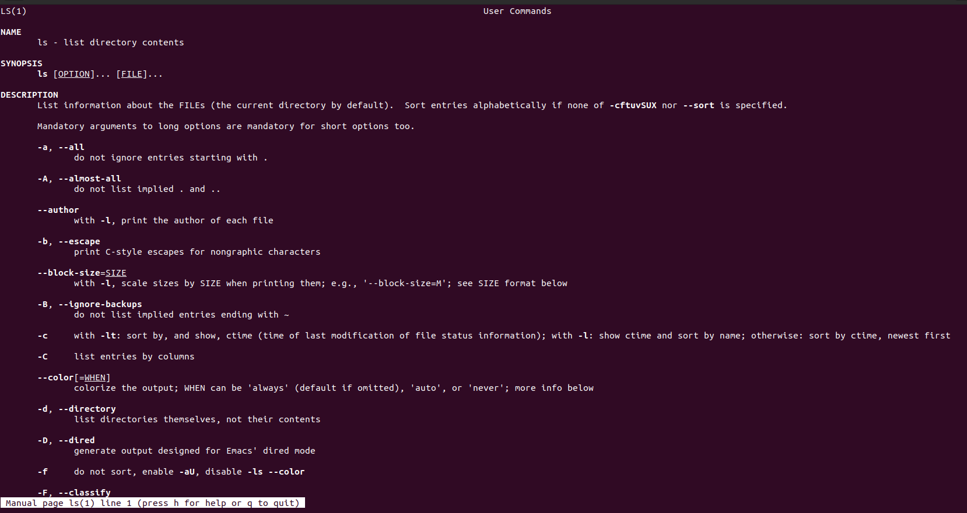



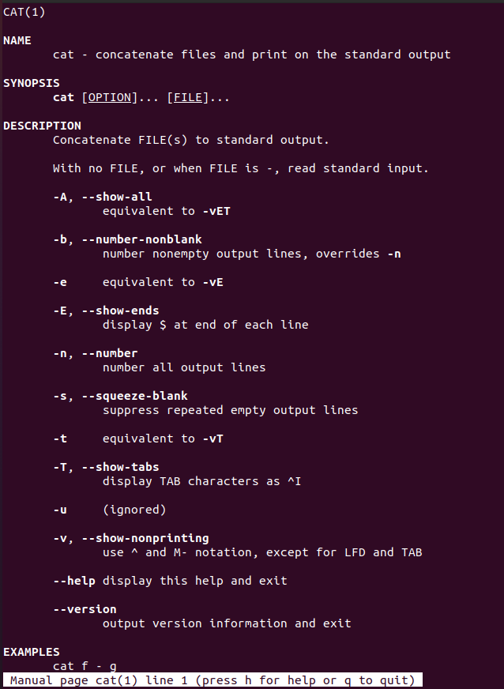

**MKDIR:**

**Description:** This command is used to create one or more directories.

**Syntax:** mkdir <directoryname>

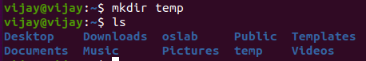

**RMDIR:**

**Description:** This command is used to remove one or more directories.

**Syntax:** rmdir <directoryname>

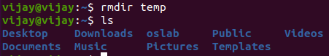

**CD:**

**Description:** The cd command, also known as chdir (change directory), is a command-line shell command used to change the current working directory.

**Syntax:** cd **<**directoryname>



**LS:**

**Description:** ls command allows to view a list of the files and folders in a given directory.

**Syntax:** ls



**CP:**

**Description:** cp command is used to copy files or group of files or directory. It creates an exact image of a file on a disk with different file name.

**Syntax:** cp <existing filename> <new filename>

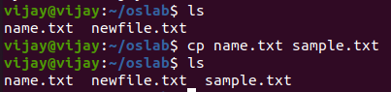

**CHMOD:**

**Description:**  The chmod command is used to change the access mode of a file. The modes indicate which permissions are to be granted or removed from the specified classes. The user classes may be owner or group members or others. The file permission in Linux are of three:

* read (r)
* write (w)
* execute (x)

**Syntax:** chmod [options] [permissions] <filename>

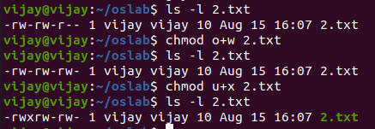

**PWD:**

**Description:** the command prints the complete path of the current working directory.

**Syntax:** pwd



**RM:**

**Description:** rm command is used to delete files.

**Syntax:** rm <filename>

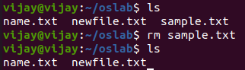

**CUT:**

**Description:** The cut command in UNIX is a command for cutting out the sections from each line of files and writing the result to standard output. It can be used to cut parts of a line by byte position, character and field. Basically, the cut command slices a line and extracts the text.

**Syntax:** cut [options].. <filename>..

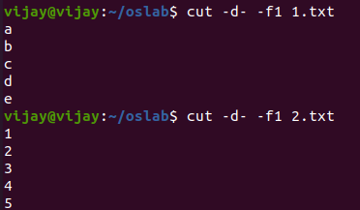

**PASTE:**

**Description:** Paste command is one of the useful commands in Unix or Linux operating system. It is used to join files horizontally (parallel merging) by outputting lines consisting of lines from each file specified, separated by tab as delimiter, to the standard output.

**Syntax:** paste [options].. <filename>..



**SORT:**

**Description:** sort command is used to sort a file, arranging the records in a particular order.

**Syntax:** sort <filename>

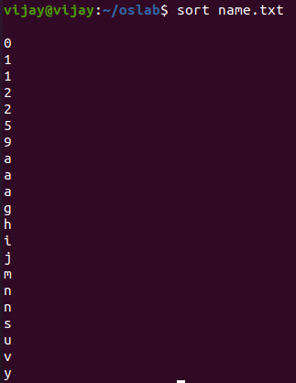

**MV:**

**Description:** The mv command moves files and directories from one directory to another or renames a file or directory.

**Syntax:**

**For moving a file to a directory:** mv <filename> <directoryname>

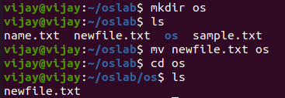

**For renaming a directory:** mv <directoryname> <directoryname>

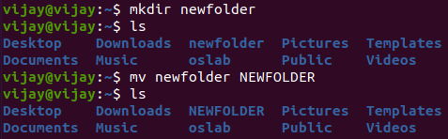

**GREP:**

**Description:** grep command will print the lines matching the given pattern in a text file.

**Syntax:** grep pattern <filename>



**FIND:**

**Description:** The find command in UNIX is a command line utility for walking a file hierarchy. It can be used to find files and directories and perform subsequent operations on them. It supports searching by file, folder, name, creation date, modification date, owner and permissions.

**Syntax:** find [where to start searching from] [expression determines what to find] [-options] [what to find]

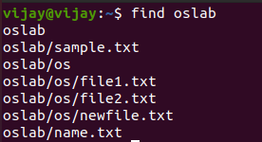

**DIFF:**

**Description:** This command is used to display the differences in the files by comparing the files line by line.

**Syntax:** diff <filename> <filename>

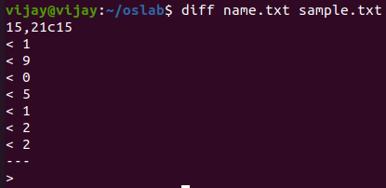

**UNIQ:**

**Description:** The uniq command finds the unique lines in a given input and either reports or removes the duplicate lines.

**Syntax:** uniq <filename>

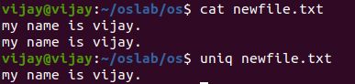

**WC:**

**Description:** wc command returns the number of lines in a file, the number of words in a file and the number of characters

in a file.

**Syntax:** wc <filename>

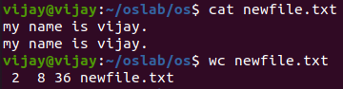

**TR:**

**Description:** The tr command in UNIX is a command line utility for translating or deleting characters. It supports a range of transformations including uppercase to lowercase, squeezing repeating characters, deleting specific characters and basic find and replace. It can be used with UNIX pipes to support more complex translation.

**Syntax:** tr [option] SET1 [SET2]

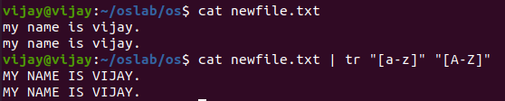

**PIPE FOR COMBINING TWO OR MORE RECORDS:**

**Description:** A pipe is a form of redirection (transfer of standard output to some other destination) that is used in Linux and other Unix-like operating systems to send the output of one command/program/process to another command/program/process for further processing.

**Syntax:** command_1 | command_2 | command_3 | ….. | command_N

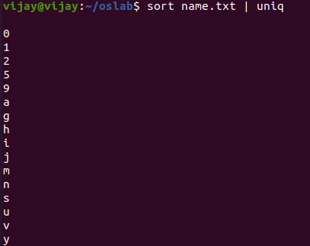

**RESULT:**

The basic unix commands have been studied and the output has been verified.